Business Name: Sales
Sales is an online platform web and mobile application to sell new and second-hand products, properties(Sale, Rent, Lease ) and foreman service chain with all. It aims to serve quality services with local and international flair.
People will sign up with our application to give services and update their feedback for every service/user. We are going to collect money based on single or package and annually, costs range from ₹50 - ₹15000. Based on comments we are going to give rating points to every user. We need to boost every advertisement based on packages and periods. All services need to be shareable with social media, We need to give provision for Google ads service.
Services:
- New and Second-hand products sale advertisement.
- Properties (Rent & Lease products/House/Lands) advertisement.
- Foreman services advertisement (Carpenter, Electricians etc.,).
- We need to segregate services based on Categories/Packages/Keywords/Location.
- Need option for Recommendations and comments.
- All services need to be shareable with social media (WhatsApp, Facebook, Instagram etc.,).
- Packages should be the Number of advertisements and periods (Days/Monthly & Yearly).
- Google AdSense provision.

Vision & Mission:
Are you looking to advertise your product or service? Look no further! We offer a seamless and efficient process for posting advertisements with confirmation.

Our platform ensures that your advertisement reaches a wide audience, maximizing your chances of success. With just a few simple steps, you can have your advertisement up and running in no time.

To begin, create an account on our user-friendly website. Once registered, you can easily navigate through our intuitive interface to craft your advertisement. Our platform provides various customization options, allowing you to tailor your ad to your specific needs.

Once you have finalized your advertisement, our system will guide you through the confirmation process. This step ensures that your ad meets all the necessary requirements and guidelines. Our team of experts will review your advertisement to guarantee its quality and compliance.

Upon successful confirmation, your advertisement will be published on our platform, reaching a vast audience of potential customers. You can track the performance of your ad through our comprehensive analytics, enabling you to make data-driven decisions for future campaigns.

We understand the importance of a professional and effective advertisement. That's why our platform is designed to provide you with the tools and support you need to create compelling ads that captivate your target audience.

Don't miss out on the opportunity to showcase your product or service to a wide range of potential customers. Post your advertisement with confirmation today and experience the benefits of our seamless and efficient process.
UX Research Study — Sales

Introduction | - Title: Sales is an online platform web and mobile application to sell new and second-hand products, Properties and foreman service chain with all. It aims to serve quality services with local and international flair.  - Author: Arumugam V, aaruraj02@gmail.com  - Stakeholders: Arumugam V | Sundaresh P  - Date: 04/09/2023  - Project background: Sales is an online platform web and mobile application to sell new and second-hand products, rent products or house/land and foreman service chain with all. It aims to serve quality services with local and international flair.  - Research goals:  - New and Second-hand products sale advertisement.  - Properties (Rent & Lease products/House/Lands) advertisement.  - Foreman services advertisement (Carpenter, Electricians etc.,).  - We need to segregate services based on Categories/Packages/Keywords/Location.  - Need option for Recommendations and comments.  - All services need to be shareable with social media (WhatsApp, Facebook, Instagram etc.,).  - Packages should be the Number of advertisements and periods (Days/Monthly & Yearly).  - Google AdSense provision.
Research
questions
Key Performance Indicators
(KPIs)
Methodology | - Unmoderated and usability study
Participants | - Participants are people who place group coffee orders at least twice a month.
Script | - Prompt 1: To begin, navigate to the home screen and proceed to create a profile.  - Prompt 2: Begin creating a tailored advertisement.  - Prompt 3: Choose a category and location for services.  - Prompt 4: Please provide an item description along with relevant images and videos for the slide, as well as any keywords associated with it.  - Prompt 5: Please choose a package or select an existing package.  - Prompt 6: Posting Advertisement with Confirmation  - Prompt 7: Share link to all social media

Users
- Customer
- Professionals (Carpenter, Electrician & etc.,)
- Retailers
- Companies
- Real estate
- Support User
- Backoffice User
- Manager User
- Administration User
- Super Admin User
Users Categories
- Customer
- Professional
- Retailer
- Support
- Backoffice
- Manager
- Admin
- Super Admin

Advertisement
Listing: New Products, Seconds, Properties (Sale/Rent/Lease )& Professionals (Foreman)
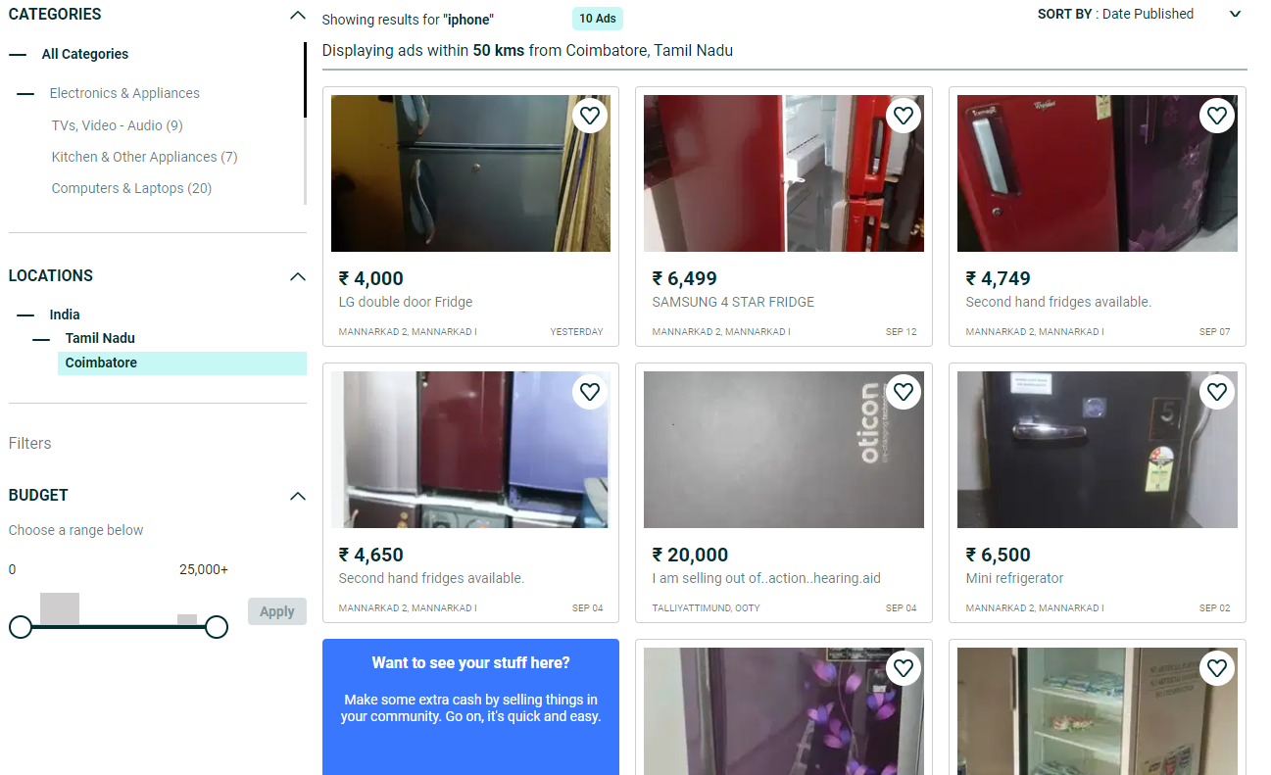
Sample Products
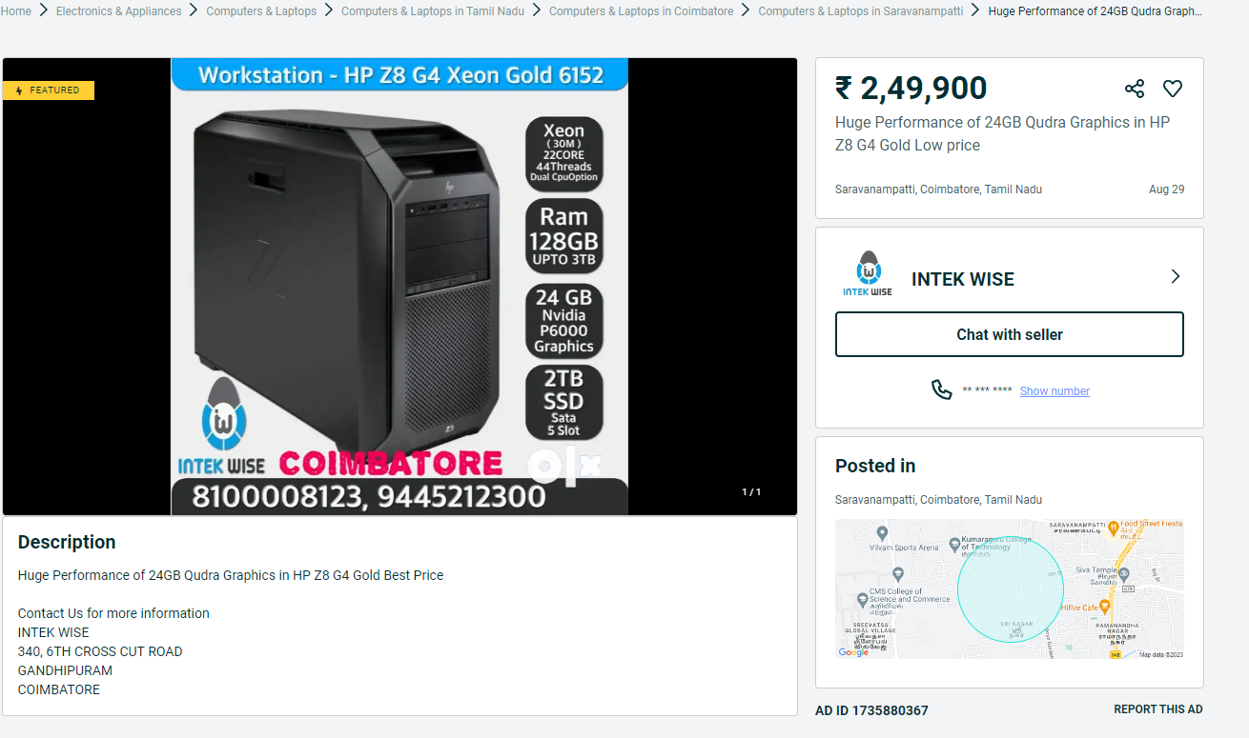

Sample Properties content
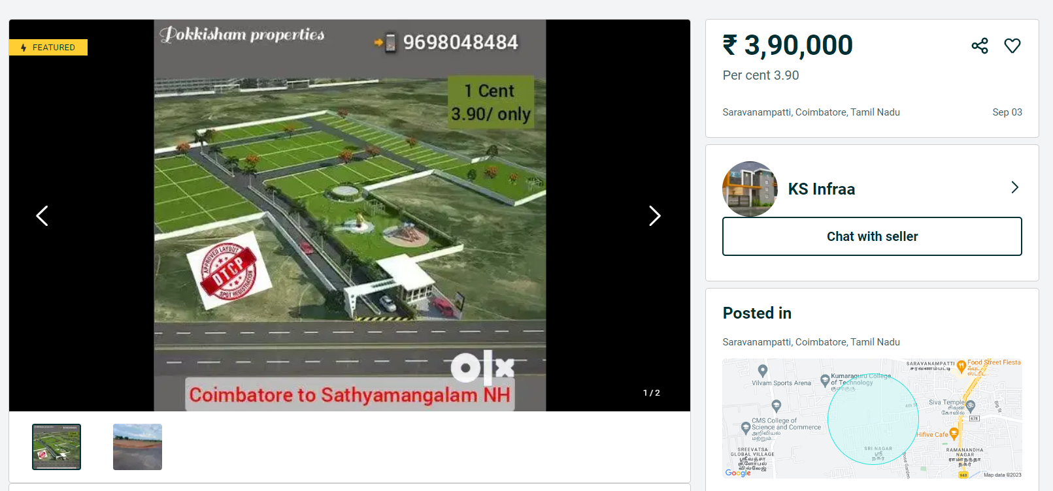
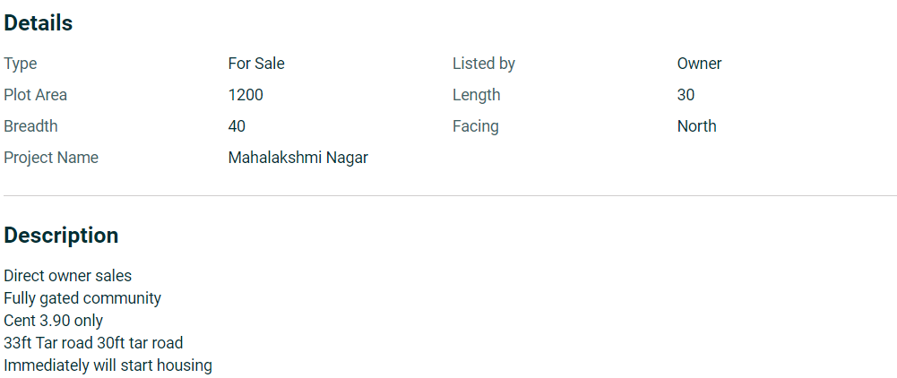

Filter option: location, Cost Range & Categories
- Professional
- Description
- Keywords
- Images/Video’s
- Packages
- Contact Information
- Social Media links
- Web URL’s
- Products (Home Appliances, Wholesale, Apparel etc.,)
  - Description
  - Keywords
  - Images/Video’s
  - Contact Information
  - Social Media links
  - Web URL’s

- Our Advertisement Packages
  - Single Ads - ₹50.00
  - Multiple Ads
1 to 5 ads - ₹200.00
1 to 10 ads - ₹500.00
1 to 25 ads - ₹1200.00
1 to 50 ads - ₹1400.00
1 to 100 ads - ₹2800.00
- Payment gateway
- Location
- Price
- Chat environment

